**Hanzla saeed**

**472684**

**Section C**

**Assignment 1**

**Q#1**

#include<iostream>

using namespace std;

int main() {

int n;

cout << "Enter a positive integer: ";

cin >> n;

cout << "Factors of " << n << " are: ";

for(int i = 1; i <= n; ++i) {

if(n % i == 0)

cout << i << " ";

}

return 0;

}

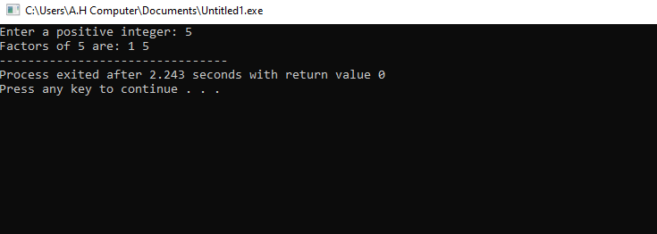

**Q#2**

The output of the code is

x is 5 and y is 10

**Q#3**

#include<iostream>

using namespace std;

int main() {

int n;

int r ;

cout<<"Enter an integer"<<endl;

cin>>n;

cout<<endl;

if(n>10&&n<=20)

{

cout<<"'1'"<<endl;

}

else

{

cout<<"'0'"<<endl;

}

return 0;

}

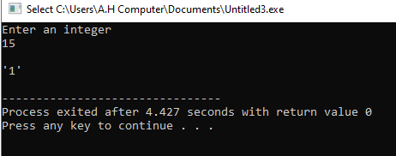

**Q#4**

#include<iostream>

using namespace std;

int main() {

int N, i;

cout << "Enter a positive integer: ";

cin >> N;

for(N=N; N > 1; N--) {

for(i = 2; i < N; i++) {

if(N % i == 0)

break;

}

if(i == N) {

cout << "The largest prime number less than or equal to your number is: " << N;

break;

}

}

return 0;

}

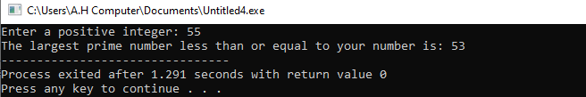

**Q#5**

#include<iostream>

#include<string>

using namespace std;

int main() {

string str1, str2;

cout << "Enter the first string: ";

cin >> str1;

cout << "Enter the second string: ";

cin >> str2;

if(str1 == str2) {

for(int i = str1.length() - 1; i >= 0; i--)

cout << str1[i];

cout << endl;

} else {

cout << "Strings are not equal." << endl;

}

return 0;

}

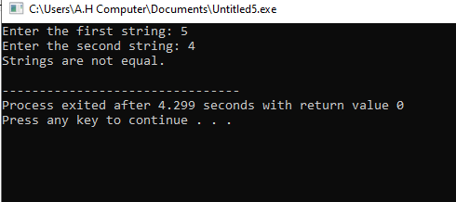

**Q#6**

#include<iostream>

using namespace std;

int main() {

int dividend, divisor, quotient = 0;

cout << "Enter the dividend (must be greater than divisor): ";

cin >> dividend;

cout << "Enter the divisor: ";

cin >> divisor;

for(; dividend >= divisor; dividend -= divisor) {

quotient++;

}

cout << "Quotient: " << quotient << endl;

cout << "Remainder: " << dividend << endl;

return 0;

}

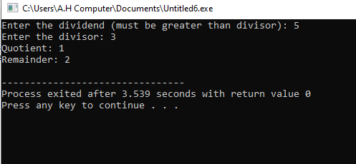

**Q#7**

#include<iostream>

using namespace std;

int main() {

char str[100], result[100] = {0};

int i, j, k = 0;

cout << "Enter a string: ";

cin >> str;

for(i = 0; str[i] != '\0'; i++) {

for(j = 0; j < i; j++) {

if(str[i] == str[j])

break;

}

if(j == i) {

result[k++] = str[i];

}

}

cout << "The string without duplicate characters is: " << result << endl;

return 0;

}

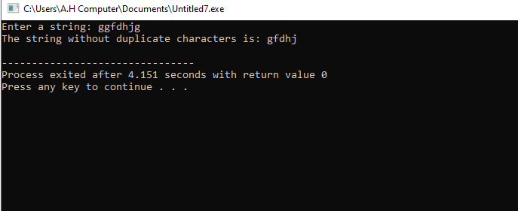

**Q#8**

#include<iostream>

using namespace std;

int main() {

int a[5] = {1,2,3,4,5};

int b[7];

for(int i = 0; i < 5; i++) {

b[i] = a[i];

}

b[5] = 6;

b[6] = 7;

for(int i = 0; i < 7; i++) {

cout << b[i] << " ";

}

return 0;

}

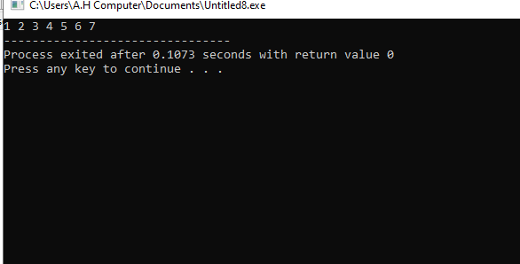

**Q#9**

#include<iostream>

using namespace std;

int main() {

int n, X, arr[100];

cout << "Enter the size of the array: ";

cin >> n;

cout << "Enter the elements of the array: ";

for(int i = 0; i < n; i++) {

cin >> arr[i];

}

cout << "Enter the value of X: ";

cin >> X;

for(int i = 0; i < n-2; i++) {

for(int j = i+1; j < n-1; j++) {

for(int k = j+1; k < n; k++) {

if(arr[i] + arr[j] + arr[k] == X) {

cout << "Triplet found: " << arr[i] << ", " << arr[j] << ", " << arr[k] << endl;

return 0;

}

}

}

}

cout << "No triplet found that sums to " << X << endl;

return 0;

}

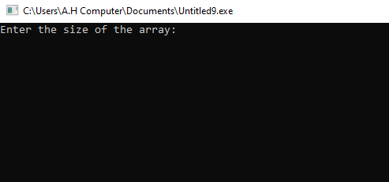

**Q#10**

#include<iostream>

using namespace std;

int main() {

int arr[6], i, j, temp;

cout << "Enter 6 integers: ";

for(i = 0; i < 6; i++) {

cin >> arr[i];

}

for(i = 0; i < 5; i++) {

for(j = 0; j < 5-i; j++) {

if(arr[j] > arr[j+1]) {

temp = arr[j];

arr[j] = arr[j+1];

arr[j+1] = temp;

}

}

}

cout << "Sorted array: ";

for(i = 0; i < 6; i++) {

cout << arr[i] << " ";

}

return 0;

}

